**Group 5 – Group work plan and team roles**

* **SCRUM Roles:**
* SCRUM Master: Angel Petrov – [266489@via.dk](mailto:266489@via.dk)
* Product Owner: Diyar Hussein – [266352@via.dk](mailto:266352@via.dk)
* **Planned Sprints:**

|  |  |  |
| --- | --- | --- |
| Sprint # | Date from | Date to |
| 1 | 15-03-2018 | 18-03-2018 |
| 2 | 19-03-2018 | 22-03-2018 |
| 3 | 23-03-2018 | 26-03-2018 |
| 4 | 27-03-2018 | 30-03-2018 |
| 5 | 31-03-2018 | 03-04-2018 |
| 6 | 04-04-2018 | 07-04-2018 |
| 7 | 08-04-2018 | 11-04-2018 |
| 8 | 12-04-2018 | 15-04-2018 |
| 9 | 16-04-2018 | 19-04-2018 |
| 10 | 20-04-2018 | 23-04-2018 |
| 11 | 24-04-2018 | 27-04-2018 |
| 12 | 28-04-2018 | 01-04-2018 |
| 13 | 02-05-2018 | 05-05-2018 |
| 14 | 06-05-2018 | 09-05-2018 |
| 15 | 10-05-2018 | 13-05-2018 |
| 16 | 14-05-2018 | 17-05-2018 |
| 17 | 18-05-2018 | 21-05-2018 |
| 18 | 22-05-2018 | 25-05-2018 |
| 19 | 26-05-2018 | 29-05-2018 |
| 20 | 30-05-2018 | 02-06-2018 |
| 21 | 03-06-2018 | 06-06-2018 |
| 22 | 07-06-2018 | 08-06-2018 |

* **Group meetings and work:**

Q: When does the group meet?

A: Group meetings are based on the SEP2 scheduled work time plus additionally specified work time frames by group members.

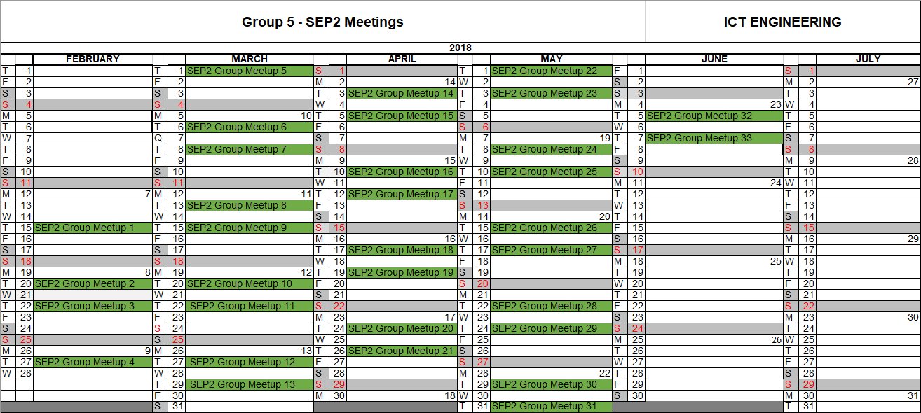

Q: Where does the group meet?

A: The group will always meet at VIA University College unless circumstances prevent that from happening.

* Average meeting time: **4 hours**.
* Average amount of hours to work during group meetup: **132 hours.**
* Total estimated amount of work on project: **1120 hours.**